Practical no. 4:

8x8 LED Grid Control (Matrix LED Programming)
- Connect an 8×8 LED matrix module • Program animations or scrolling text patterns
- Explore logical formulas for patterns

Components
- Arduino UNO
- LEDs
- Resistors (220Ω)

Connections:

ROW Pins (Anodes → Arduino)
Row | Arduino Pin
R0 | 2
R1 | 3
R2 | 4
R3 | 5
R4 | 6
R5 | 7
R6 | 8
R7 | 9

COLUMN Pins (Cathodes → via Resistors → Arduino)
Column | Arduino Pin
C0 | 10
C1 | 11
C2 | 12
C3 | 13
C4 | A0
C5 | A1
C6 | A2
C7 | A3
- Each column must have one resistor (220Ω)

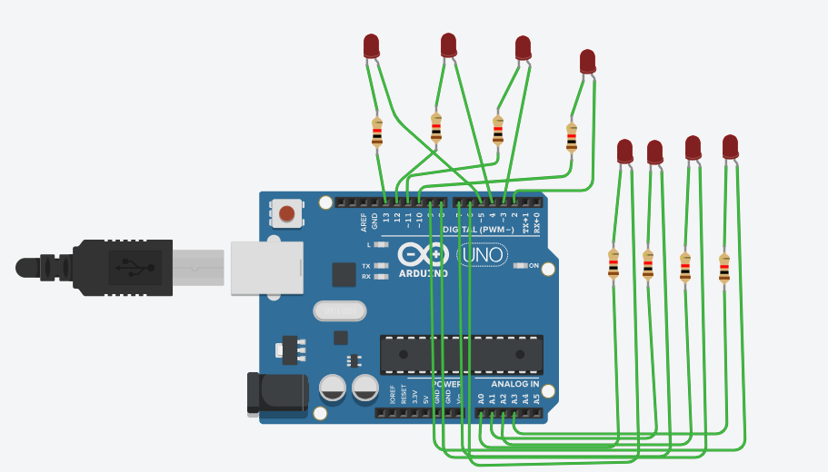

Code:

int rowPins[8] = {2,3,4,5,6,7,8,9};
int colPins[8] = {10,11,12,13,A0,A1,A2,A3};

void setup() {
for(int i = 0; i < 8; i++) {
pinMode(rowPins[i], OUTPUT);
pinMode(colPins[i], OUTPUT);
}
}

void loop() {
showDiagonal(); // display diagonal pattern
}

// Display diagonal LEDs
void showDiagonal() {
for(int row = 0; row < 8; row++) {

digitalWrite(rowPins[row], HIGH); // activate row

for(int col = 0; col < 8; col++) {
if(row == col) {
digitalWrite(colPins[col], LOW); // LED ON
} else {
digitalWrite(colPins[col], HIGH); // LED OFF
}
}

delay(2); // small delay for multiplexing
digitalWrite(rowPins[row], LOW); // deactivate row
}
}

Output:
